# **Project Documentation: Login Form Application**

GROUP MEMBERS

Myrrah Muoria p01/0276/2022

Glen Kamau p01/0011/2022

Solomon Kaniaru p01/0204/2022

John Mungai p01/0127/2022

**Table of Contents**

-Introduction

1.1 Purpose

1.2 Scope

-User Requirements

-Design for the Application

3.1 User Interface (UI) Design

3.2 System Architecture

3.3 Data Storage

-Implementation

4.1 Tools and Technologies

4.2 Development Environment

-Testing

5.1 Unit Testing

5.2 Integration Testing

5.3 User Acceptance Testing

-Deployment

-Maintenance and Support

-Conclusion

1. Introduction

1.1 Purpose

The purpose of this document is to provide a comprehensive understanding of the login form application developed using Microsoft .NET and Visual Studio. It includes the analysis of user requirements, design considerations, and implementation details.

1.2 Scope

This application aims to create a secure and user-friendly login form for authenticating users into a system. The application will be developed using the Microsoft .NET framework and Visual Studio.

2. User Requirements

The following are the user requirements for the login form application:

User Authentication: Users should be able to log in using a valid username and password.

Registration: Users can create new accounts by providing necessary information, which will be stored securely.

Security: Passwords must be stored securely using encryption and salt techniques.

User-Friendly GUI: The application should have an intuitive and user-friendly graphical user interface (GUI).

3. Design for the Application

3.1 User Interface (UI) Design

The GUI for the login form application will include the following components:

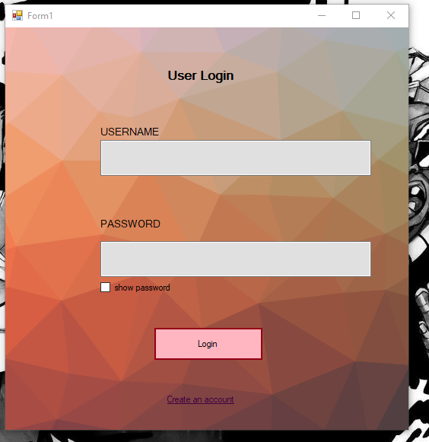

Username and Password Fields: These will be input fields where users can enter their login credentials.

Login Button: Pressing this button will validate the user's credentials and grant access.

Register Button: This button will lead to a registration page for new users.

Error Messages: If login credentials are incorrect, appropriate error messages will be displayed.

Sample Menu page: After a successful Login the user is taken to a blank login page to show authentication success

3.2 System Architecture

The application will follow a three-tier architecture:

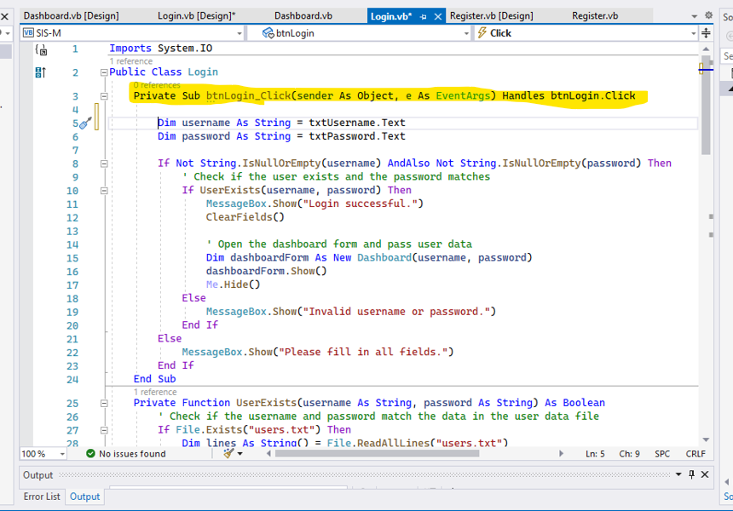The Yellow highlight Represents the :

-Creation of event source

- Creation of event handler

-Registration of event handler

-The code layout that handles the event

Presentation Layer: The GUI is created using Windows Forms in Visual Studio.

Business Logic Layer: This layer handles authentication and registration.

Data Access Layer: User information and credentials are stored and retrieved from a secure database.

3.3 Data Storage

User information, including usernames and securely hashed passwords, will be stored in a relational database system. A MySQL Server will be used for this purpose.

4. Implementation

4.1 Tools and Technologies

Microsoft Visual Studio for development.

Microsoft .NET framework for building the application.

MySQL Server for database management.

Visual basics for programming the application logic.

4.2 Development Environment

The application will be developed in Visual Studio, targeting the .NET framework. The database will be managed using SQL Server Management Studio.

5. Testing

5.1 Unit Testing

Unit tests will be conducted to ensure that individual components of the application (e.g., user authentication, password hashing, and database interactions) are functioning correctly.

5.2 Integration Testing

Integration testing will verify that the different layers of the application work together seamlessly.

5.3 User Acceptance Testing

End-users will perform testing to ensure the application meets their requirements and is user-friendly.

6. Deployment

The application will be deployed on a server with appropriate security measures to protect user data.

7. Maintenance and Support

Regular maintenance and updates will be performed to address any security vulnerabilities, user feedback, or changes in technology.

8. Conclusion

This project documentation provides a comprehensive overview of the login form application developed using Microsoft .NET and Visual Studio. It outlines the user requirements, design considerations, and implementation details, ensuring that the application meets the needs of the users and maintains a high level of security.